1. List the top 3 and bottom 3 makers for the fiscal years 2023 and 2024 in terms of the number of 2-wheelers sold.

TOP 3

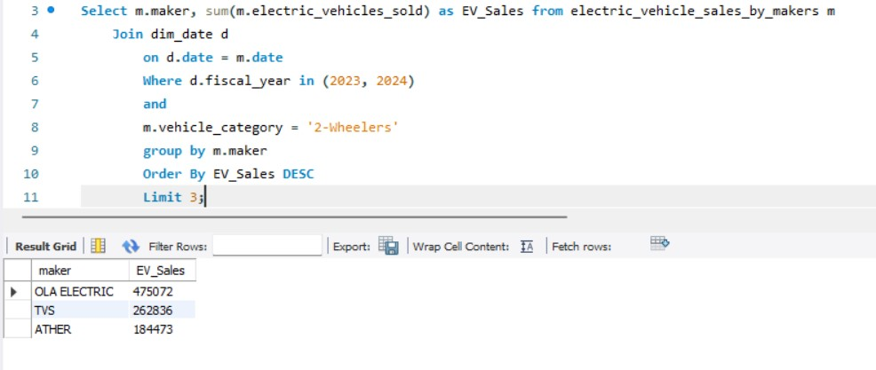

BOTTOM 3

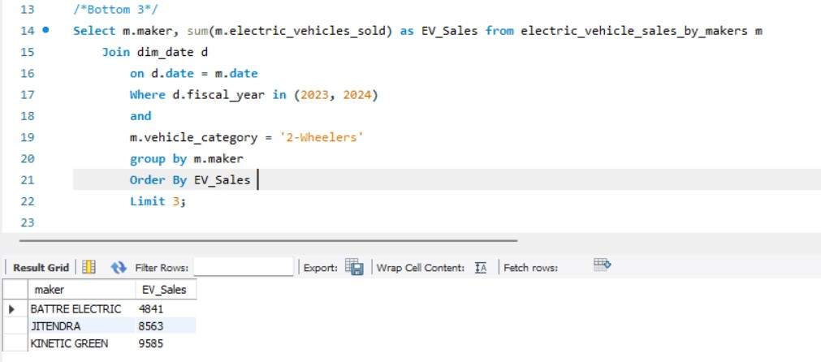

1. Identify the top 5 states with the highest penetration rate in 2-wheeler and 4-wheeler EV sales in FY 2024.

2 WHEELERS

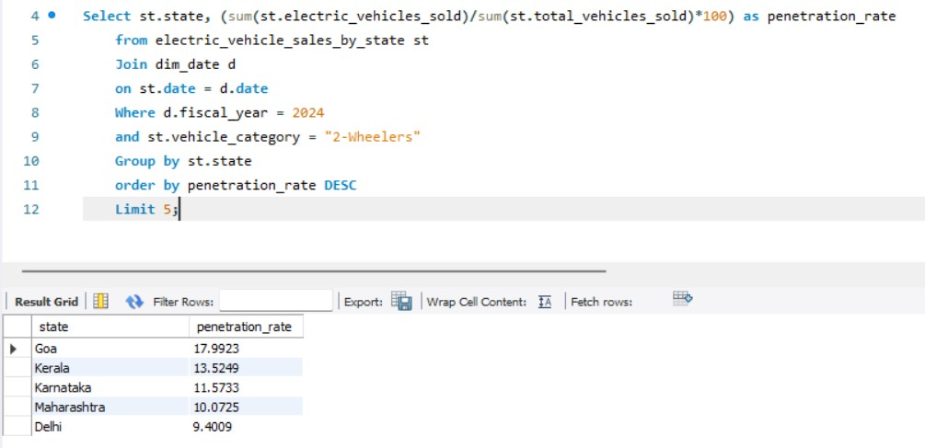

4 WHEELERS

1. List the states with negative penetration (decline) in EV sales from 2022 to 2024?

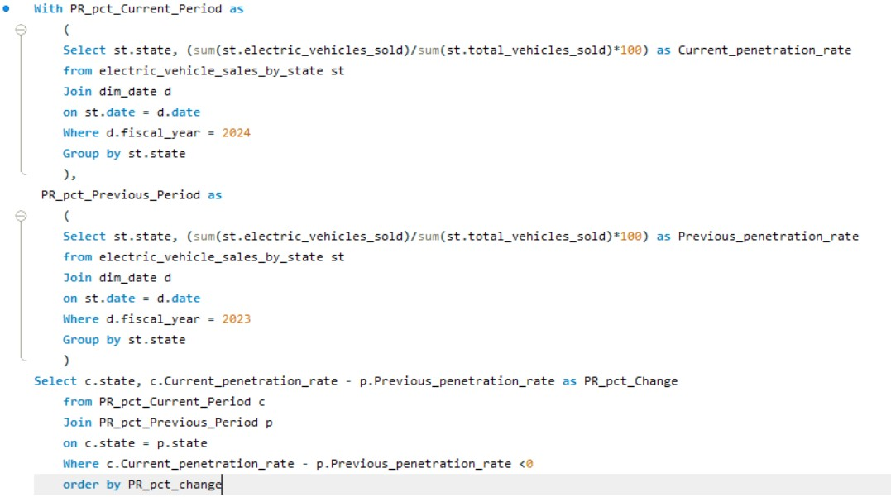

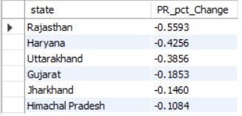 STORED PROCEDURE

1. What are the quarterly trends based on sales volume for the top 5 EV makers (4-wheelers) from 2022 to 2024?

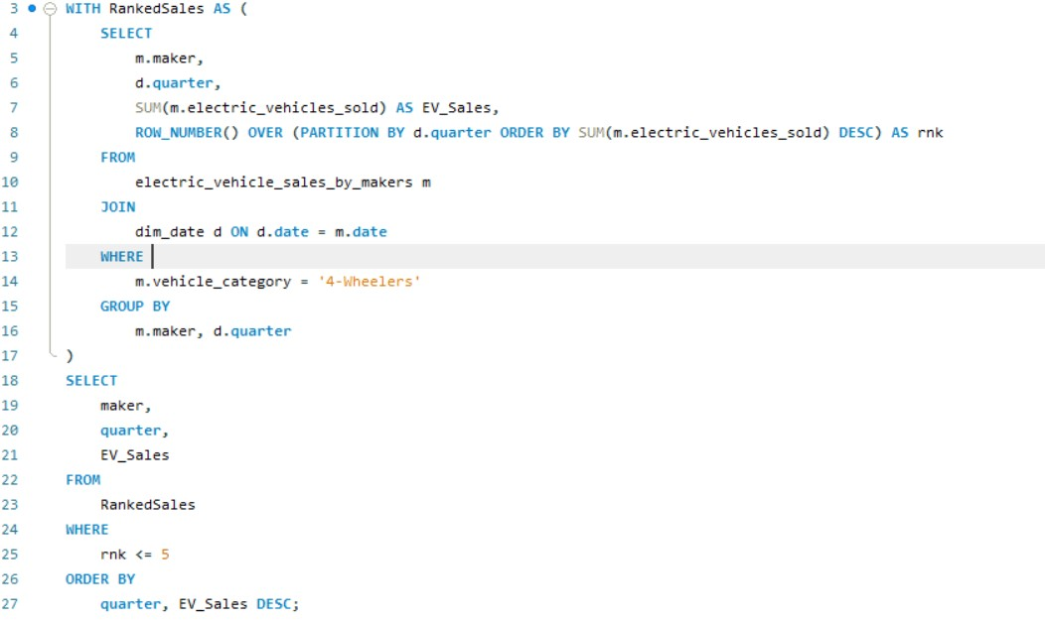

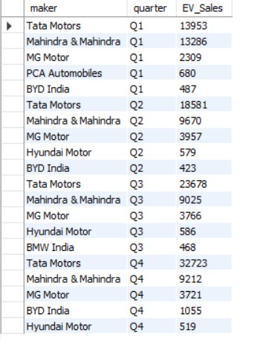

1. How do the EV sales and penetration rates in Delhi compare to Karnataka for 2024?

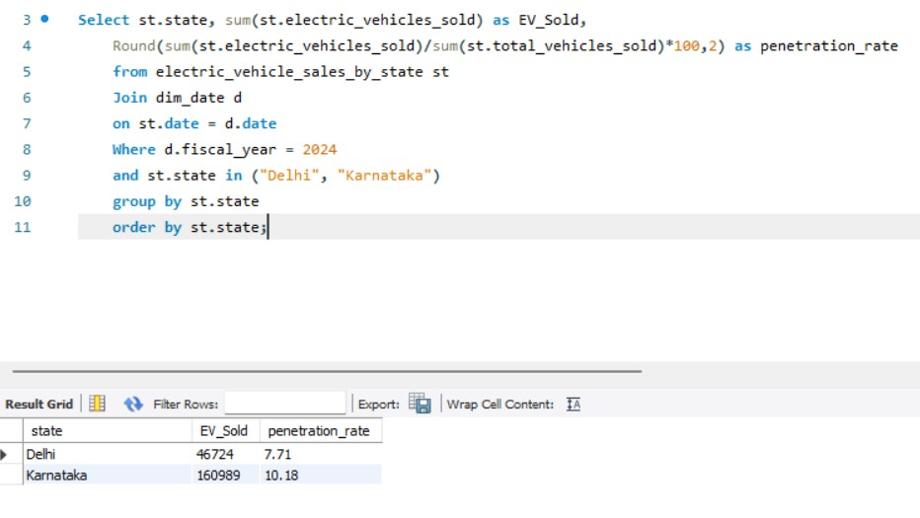

1. List down the compounded annual growth rate (CAGR) in 4-wheeler units for the top 5 makers from 2022 to 2024.

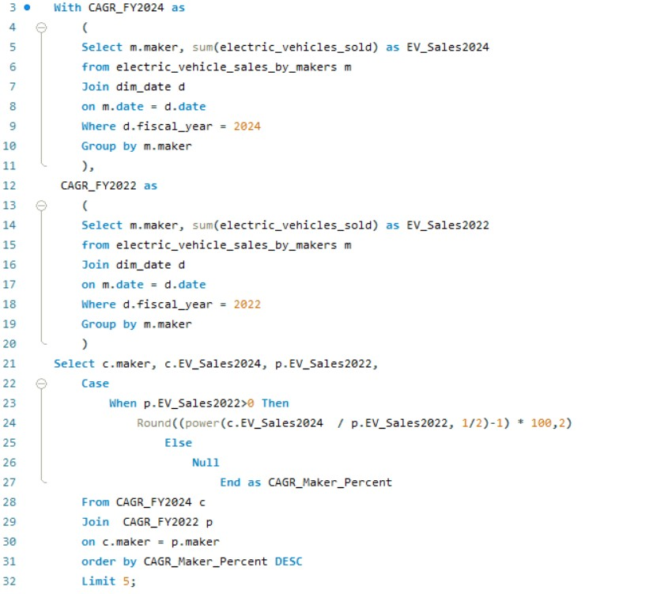

1. List down the top 10 states that had the highest compounded annual growth rate (CAGR) from 2022 to 2024 in total vehicles sold.

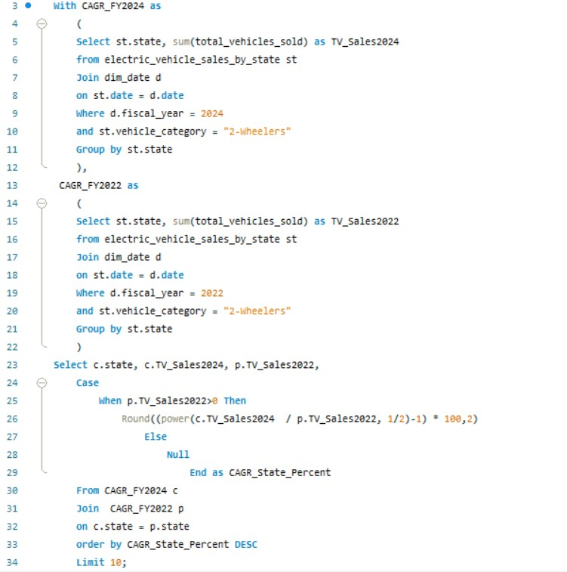

2 WHEELERS

1. What are the peak and low season months for EV sales based on the data from 2022 to 2024?

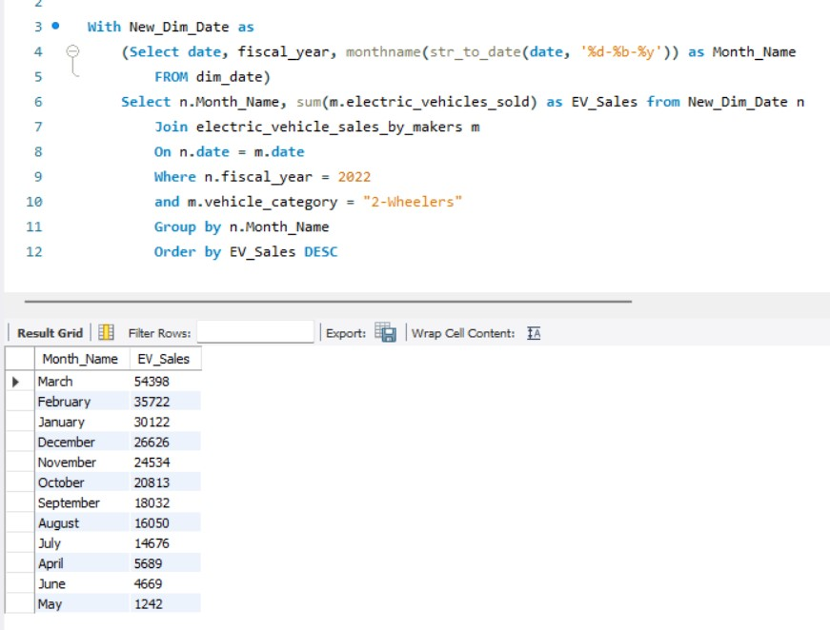

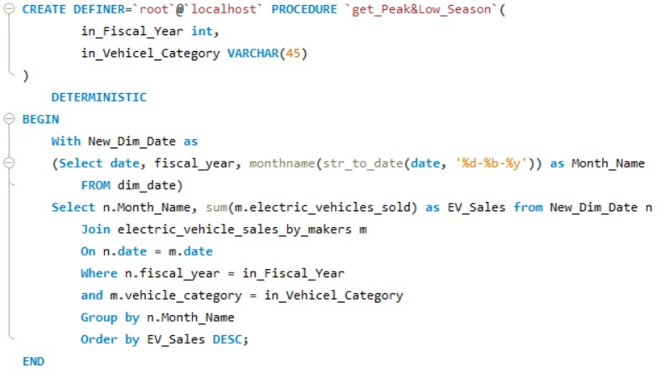

1. What is the projected number of EV sales (including 2-wheelers and 4-wheelers) for the top 10 states by penetration rate in 2030, based on the compounded annual growth rate (CAGR) from previous years?

QUERY TO CREATE VIEW TABLE FOR CAGR %

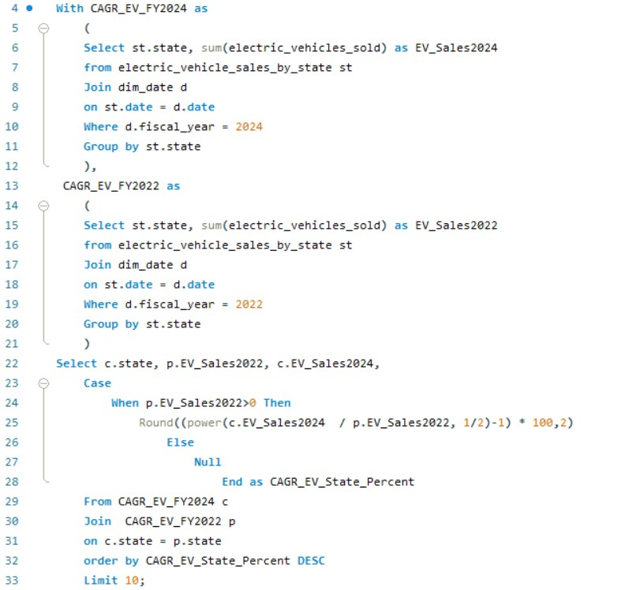

PENETRATION VIEW TABLE

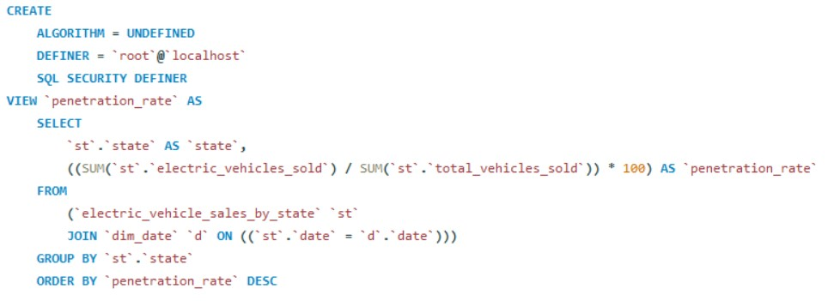

QUERY USING VIEW TABLE

